*Proceedingsofthe 8thConf.Int. ForumUrban.*, E013,doi:10.3390/ifou-E013.



# InnovativeToiletTechnologiesforSmartandGreenCities

**Abstract:**Forthewaytoasmartandgreenurbansociety,sanitationisanimportantconcern.Currentl y,usingtoiletsisneithersmartnorgreen.Everyflushofcommontoiletssendsabout13 - 16 liters of fresh water to wastewater treatment centers. These processes require 3 – 15kWh for treating just one cubic meter of wastewater. Another problem is the mixing of urineand feces from the source, necessitating wastewater treatment. This treatment leads to thewaste of a high amount of valuable nutrients in the urine, and causes many environmentalproblems. Also due to common technical water supply problems such as pipe blockage,current toilet systems are not functional in disasters or other emergency situations.

However,manyoftheseproblemscanbesolvedusingsmarterdesigns.Inthisstudy,innovativedesig nshavebeensuggestedfortoiletsystems.Thesedesignsuselessornowaterforreducingwaterconsu mption, apply systems such as bi-sloped conveyor belts to separate the urine and fecesinto two different tanks with biological digestion processes, improve flushing systems usingalternative methods to reduce pipe blockage potential, and use special light and handy toiletseats for sanitation in emergency. Following these designs, new products have been made

inlabscaletoprovethattheseinnovativetechnologiescanreducewaterandenergyconsumption, thereby taking positive steps towards building smarter and greener cities in thefuture.

**Keywords:** Green City; Smart Technologies; Sanitation; Source Separation; Emergency;WaterConsumption.

## **1. Introduction**

Sanitation is a natural and essential part of human life, and it is an important concern for sustainablegreenandsmartcityplanning.However,currentsanitationpracticesarenotsustainable.

Due to the many problems that arise from inappropriate practices and management, there are 2.5billionpeoplewhostilldonotuseimprovedsanitationfacilities,andover1billionpeoplepracticeopendefec ation (UN Human Right to Water and Sanitation, 2012). Therefore, finding sustainable solutionstothese problems is an essentialconceptinmodernurbanism.

The practice and management of sustainable sanitation has a very long history, and evidence ofancientsanitationmanagementcanbefoundallovertheworld(Brackenetal.,2006).InancientKoreansocieti es, it was well known that urine and feces could enhance land fertility if kept separate from eachother and not exposed to water. Following this concept, temple toilets (Haewooso) were designed todepositthefecesintowell-

ventilatedcompostchambers.Thefeceswerethenremovedfromthebottomofthesechambersanduseddirectly asfertilizer(Figure1).Additionally,ancientKoreanswerefamiliarwith source separation, and they had special instruments for separation and manual transportation ofexcreta (Figure2)(Han& Kim2014).

## **Figure1.**TempleToiletsNexttoHousesandAgricultureAreas

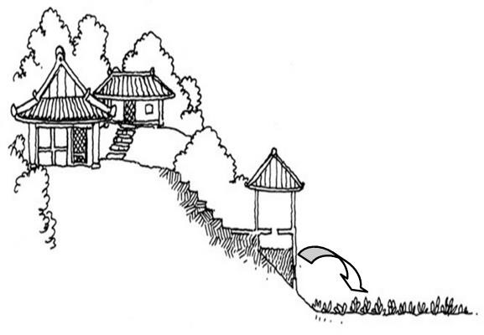

Looking to the past may help to provide solutions to current sanitation problems. By using thishistorical knowledge, and by applying modern technologies, it might be possible to find sustainablesolutions.Inthispaper,themajorproblemsofcurrenttoiletpracticesinurbanareashavebeenidentifi ed,and by following ancient wisdom in sanitation management, solutions have been suggested throughinnovativesmart-designtoilets.

### 2. MajorProblems ofCurrent SanitationPractices

#### 2.1. UsingTooMuchWaterandEnergy

Current sanitation practices have high water and energy consumption. A typical toilet consumesbetween13and15litersofwaterperflush.Usingthisinformation,asimplecalculationshowsthatabo ut10,000m3offreshwaterisconsumedoverthe20-yearlifespanofonlyonetoilet.Additionally,when considering the energy consumed to prepare flushing water for toilets through water treatment fromdams, desalination, and wastewater treatment, and also taking into account the energy for

treatment oftheflushedwater,about3–

15kWhisneededinordertotreat1m3offlushingwater(Han&Kim2014).

## **Figure2.**TraditionalManualTransportationofUrine(Left)andFeces(Right)

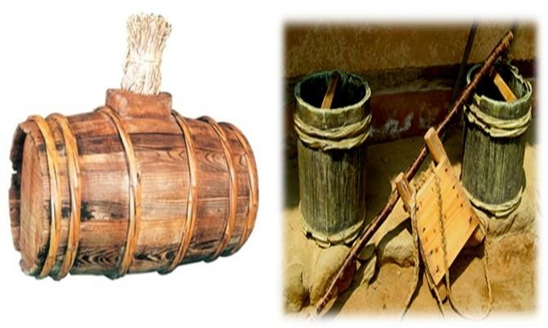

### *2.2. MixingUrineandFeces(MakingBlack-Water)*

Duetothehighamountofnutrientsinurine,themixingofurineandfecesinsanitationisawastefulpractice.Se ndingthemixtureofurineandfecestowastewatertreatmentplantsnotonlywastesimportantnutrientssuchasnit rogenandphosphorus,butcanalsoleadtoalgaesludgeover-growthinthetreatmentplants (Hashemi, 2015). Furthermore, releasing black-water back into nature can transfer contaminantssuchas PPCP, ECD, and micro pollutants intootherwaterresources(Han&Kim2014).

### *2.2.ImproperEmergencyFunctionandSocialResponsibility*

Current sanitation practices are not functional during emergencies and disasters, In these situations,water scarcity and damage to the water supply may result due to the higher and more severe demandsonthesystem(Tayleretal*.*2003).Duringdiseaseoutbreaks,suchastherecentEbolaepidemic,viruses can be easily transmitted through shared toilets (Morella & Foster 2008). Additionally, with improperpractices such as open defecation, social problems such as sexual harassment can result due to the lackof privacy (Gatherer 2014).

### 3. IntroducingInnovativeProductsforSolvingSanitationProblems

This century has seen many tremendous achievements through the innovative use of technology. Byfollowing ancient wisdom in the case of sanitation, and by using Hi-Tech, it is possible to solve manyof the sanitation problems that plague our cities today. In this case, three lab-scale products are beingintroducedas follows:

## **Figure3.**ImprovedFlushingMechanismin the4.5-LiterWater-Saving Toilet

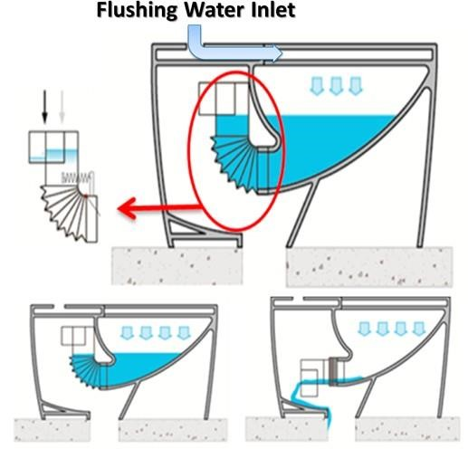

## **Figure4.**UrineSourceSeparatorBasketforthe4.5-LiterWater-SavingToilet

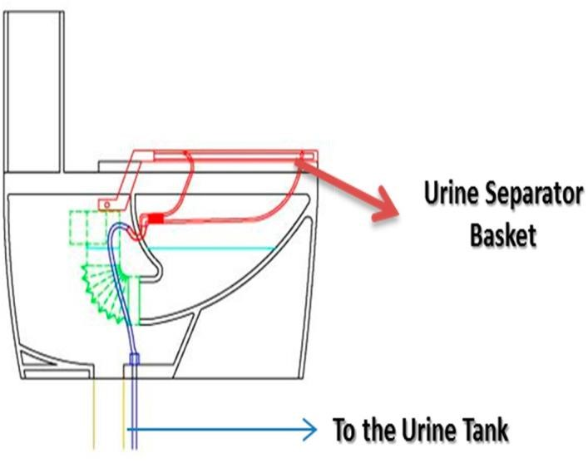

### *3.1. 4.5-LiterWater-SavingToilet*

Siphons are necessary for keeping water inside the pipe and bowl of the toilet in order to preventodor. However, the use of large amounts of water for flushing results in the improper functioning ofthesesiphons.The poorpipingdesignofsiphonsis alsothemaincauseofpipe blockage in toilets.

As it is presented in figure 3, in the new water-saving toilet, the siphon system has been redesignedand substituted with a spring. By increasing the height of water the center of gravity shifts to the leftwhenflushing.Thispushesthespringdownsothatthewastewillbedischargedfromthetoiletallowingflushi ng to be done with only 4.5 liters of water. After discharge, the spring comes back and the waterwillbe tapped, preventing the smell.

In addition, a special basket has been designed in order to separate the urine and feces (Figure 4).This basket is also useful for sending urine into a separate reservoir to be utilized for other purposes,such as for fertilizer.

### *3.2. Bi-SlopedConveyorBeltToilet*

TheBi-

SlopedConveyorBeltToiletiswaterless.Insteadofflushing,thefecesandurineareseparatedfromthesourceusi ngabi-slopedconveyorbelt(Figure6).Theconveyorbeltdeliversfecestothebackwhere they are deposited in the feces tank. The urine flows down to the front, which leads to the

urinetank.Theuseofadditivesormicroorganismbio-seedsintheurineandfecestankscancreateabiotank,convertingtheurineandfeces into fertilizers.

**Figure6.**Bi-Sloped ConveyorBelt Toiletfor SeparationandRecyclingPurposes

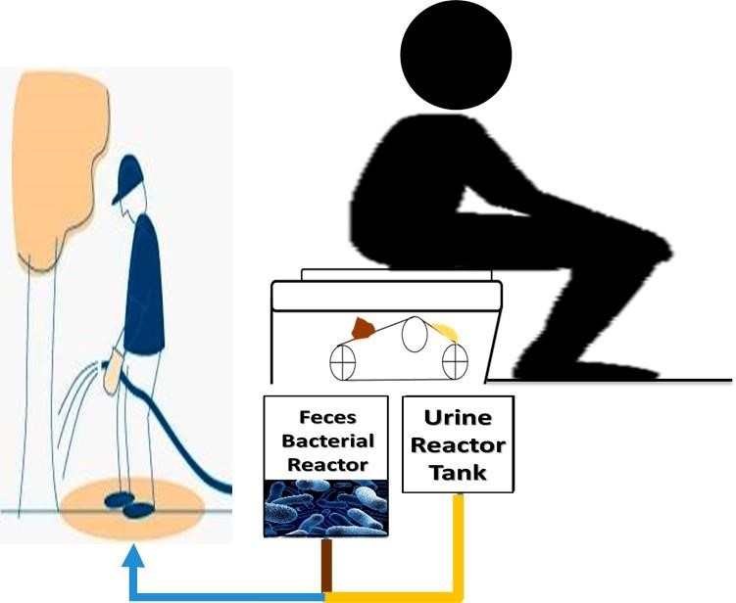

### *3.3. EmergencyEnabled WaterlessPortablePrivate Toilet Kit*

This toilet system is actually a package designed for use in emergency situations. The packagecontainsa toiletseat, awaste collectingbag,wasteadditives,andatent.

The toilet seat is made of paperboard which can be folded, and which can tolerate up to 300 kg ofweight. The waste collecting bag is made from biodegradable materials, and the additives can be addedtowastecollectingbaginordertoreducethevolumeofwaste.Thetentinthepackagecreatesaprivatespace for the user and can prevent open defecation, which will help to reduce sexual harassment andothersocialproblems(Figure7).

This toilet kit is designed for one individual so that it can reduce the potential of virus transmissionduring outbreaks. Considering the materials, the price of this kit is very low, and it can be used byeveryone.

## **Figure7.**PortablePrivateToiletApplicableforEmergencySituations

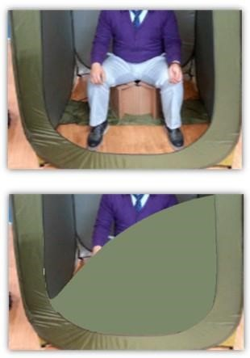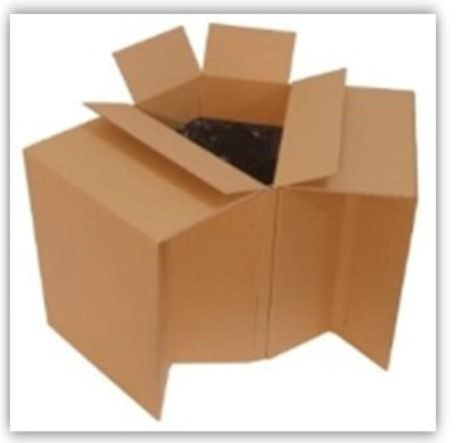

### 4. Conclusions

In this paper, we have identified major problems of current toilet practices in urban areas. Theseproblems that exist within urban sanitation systems should be considered and resolved using smart andgreen urbanismpractices.

To solve these problems, this paper suggests several innovative designs for toilet practices.

ThesedesignswereinfluencedbyancientKoreanwisdomandwererealizedbyapplyingmoderntechnologies. Throughthe useoftheseinnovations,futuresanitationpracticeswill:

1. UseLessWater
2. SeparateUrineandFeces
3. UtilizeWasteasFertilizer
4. FosterSocialResponsibility
5. BeIdentified asa Technologytoward Zero EmissionCommunity.

## **Acknowledgments**

“CommunityResourceOrientedSourceSeparationTechnologies(CROSS)”,theprojectofministryof environment of Republic of Korea and Seoul National University, is acknowledged for the financialsupportof this study.

## **ConflictofInterest**

Theauthorsdeclarenoconflictofinterest.